Identifying Bums & Adulterous Hoes

What the scriptures say to become a man?

2 Timothy 2:15 Study to shew thyself approved unto God, a workman that needeth not to be ashamed, rightly dividing the word of truth.

As men, you must study.

Ecclesiastes 12:13 Let us hear the conclusion of the whole matter: Fear God, and keep his commandments: for this is the whole duty of man.

1 Kings 2:1 Now the days of David drew nigh that he should die; and he charged Solomon his son, saying,

-King David was about to die

1 Kings 2:2 I go the way of all the earth: be thou strong therefore, and shew thyself a man;

1 Kings 2:3 And keep the charge of the LORD thy God, to walk in his ways, to keep his statutes, and his commandments, and his judgments, and his testimonies, as it is written in the law of Moses, that thou mayest prosper in all that thou doest, and whithersoever thou turnest thyself:

-a lot of men aren’t keeping the charge of God, which is why we have a lot of deadbeats, niggas, and bums

Revelation 14:12 Here is the patience of the saints: here are they that keep the commandments of God, and the faith of Jesus.

2 Samuel 19:24 And Mephibosheth the son of Saul came down to meet the king, and had neither dressed his feet, nor trimmed his beard, nor washed his clothes, from the day the king departed until the day he came again in peace.

-descendant of Saul
-a lot of men don’t want to trim their beard and look unkempt
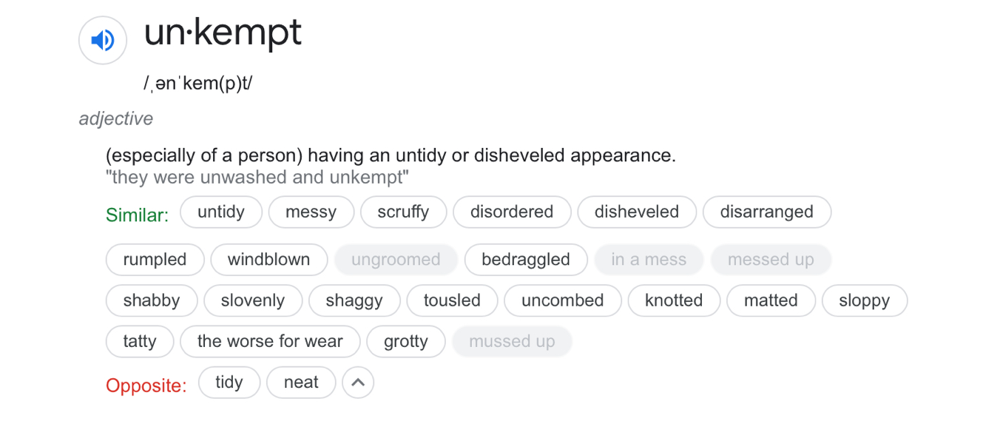

2 Samuel 19:24 And Mephibosheth the son of Saul came down to meet the king, and had neither dressed his feet, nor trimmed his beard, nor washed his clothes, from the day the king departed until the day he came again in peace.

2 Thessalonians 3:10 For even when we were with you, this we commanded you, that if any would not work, neither should he eat.

-if you don’t work, you don’t eat

2 Thessalonians 3:11 For we hear that there are some which walk among you disorderly, working not at all, but are busybodies.

Ecclesiasticus 7:15 Hate not laborious work, neither husbandry, which the most High hath ordained.

Ecclesiasticus 29:21 The chief thing for life is water, and bread, and clothing, and an house to cover shame.
Ecclesiasticus 29:22 Better is the life of a poor man in a mean cottage, than delicate fare in another man's house.

-get your own house; you can’t have 2 lions in the house

Ecclesiasticus 29:23 Be it little or much, hold thee contented, that thou hear not the reproach of thy house.

-whether you have a little or a lot, be content with what you have

Ecclesiasticus 29:24 For it is a miserable life to go from house to house: for where thou art a stranger, thou darest not open thy mouth.
Ecclesiasticus 29:25 Thou shalt entertain, and feast, and have no thanks: moreover thou shalt hear bitter words:
Ecclesiasticus 29:26 Come, thou stranger, and furnish a table, and feed me of that thou hast ready.
Ecclesiasticus 29:27 Give place, thou stranger, to an honourable man; my brother cometh to be lodged, and I have need of mine house.
Ecclesiasticus 29:28 These things are grievous to a man of understanding; the upbraiding of houseroom, and reproaching of the lender.

Matthew 19:5 And said, For this cause shall a man leave father and mother, and shall cleave to his wife: and they twain shall be one flesh?

-in order to cleave to a wife, you need somewhere to stay on your own

1 Corinthians 7:2 Nevertheless, to avoid fornication, let every man have his own wife, and let every woman have her own husband.

-there is no sharing of spouses

How do you know if you’re a bum or not?

1st verse of TLC-No Scrubs
Gwen Guthrie- Ain’t Nothin’ Going on but the rent
Video of Kevin Samuels on using baby wipes

https://ezinearticles.com/?12-Signs-That-You-May-Be-Dating-a-Bum!&id=7493395
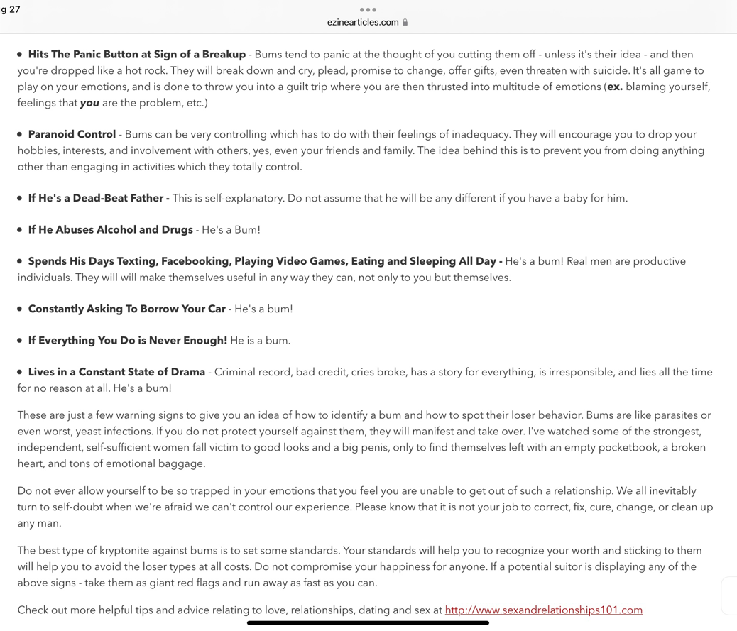
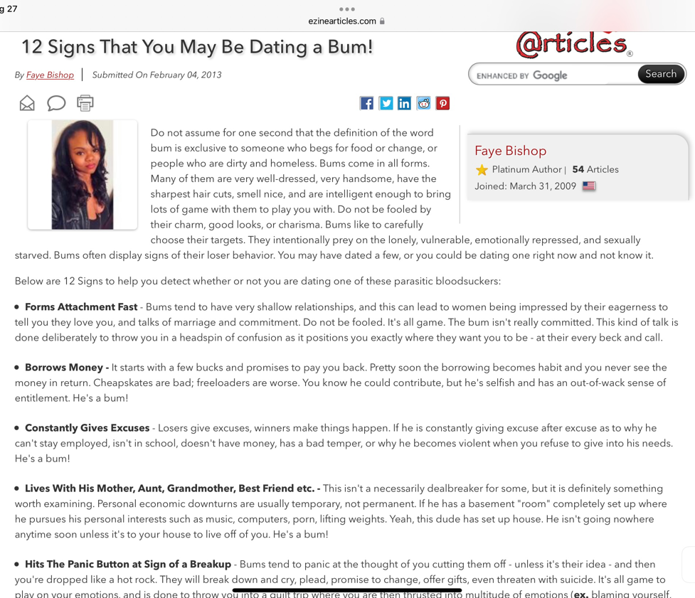

He’s a hobosexual; he’s a bum that has good sex

Ecclesiasticus 6:7 If thou wouldest get a friend, prove him first and be not hasty to credit him.
Ecclesiasticus 6:8 For some man is a friend for his own occasion, and will not abide in the day of thy trouble.

Kevin Samuels video (1hr 54 seconds start)
https://www.youtube.com/watch?v=fxP3jY8uB_w

Sisters can be bums too!

Proverbs 26:13 The slothful man saith, There is a lion in the way; a lion is in the streets.

-making crazy excuses as to why they can’t work and take care of themselves

Ecclesiasticus 40:28 My son, lead not a beggar's life; for better it is to die than to beg.
Ecclesiasticus 40:29 The life of him that dependeth on another man's table is not to be counted for a life; for he polluteth himself with other men's meat: but a wise man well nurtured will beware thereof.
Ecclesiasticus 40:30 Begging is sweet in the mouth of the shameless: but in his belly there shall burn a fire.

Ecclesiasticus 18:33 Be not made a beggar by banqueting upon borrowing, when thou hast nothing in thy purse: for thou shalt lie in wait for thine own life, and be talked on.

-some brothers love to borrow money

Ecclesiasticus 11:29 Bring not every man into thine house: for the deceitful man hath many trains.

Judge Lynn Toler Video

Ecclesiasticus 11:29 Bring not every man into thine house: for the deceitful man hath many trains.

-have many ways to get into your house

Ecclesiasticus 11:30 Like as a partridge taken and kept in a cage, so is the heart of the proud; and like as a spy, watcheth he for thy fall:
Ecclesiasticus 11:31 For he lieth in wait, and turneth good into evil, and in things worthy praise will lay blame upon thee.
Ecclesiasticus 11:32 Of a spark of fire a heap of coals is kindled: and a sinful man layeth wait for blood.
Ecclesiasticus 11:33 Take heed of a mischievous man, for he worketh wickedness; lest he bring upon thee a perpetual blot.
Ecclesiasticus 11:34 Receive a stranger into thine house, and he will disturb thee, and turn thee out of thine own.

Ecclesiasticus 36:26 Who will trust a thief well appointed, that skippeth from city to city? so who will believe a man that hath no house, and lodgeth wheresoever the night taketh him?

John 1:37 And the two disciples heard him speak, and they followed Jesus.
John 1:38 Then Jesus turned, and saw them following, and saith unto them, What seek ye? They said unto him, Rabbi, (which is to say, being interpreted, Master,) where dwellest thou?

-they wanted to know where Jesus’ house

John 1:39 He saith unto them, Come and see. They came and saw where he dwelt, and abode with him that day: for it was about the tenth hour.

-He showed them where he lives

Video: Bumology 101

“A big butt and a smile will get you a “ho-man” and possibly a short marriage (less than 1 year); but a sister with kindness, integrity, and a good character will keep you married.”

Ecclesiasticus 23:17 All bread is sweet to a whoremonger, he will not leave off till he die.

Ecclesiasticus 25:2 Three sorts of men my soul hateth, and I am greatly offended at their life: a poor man that is proud, a rich man that is a liar, and an old adulterer that doateth.

-he can’t stop; he’s fond of doing that

Ecclesiasticus 26:9 The whoredom of a woman may be known in her haughty looks and eyelids.

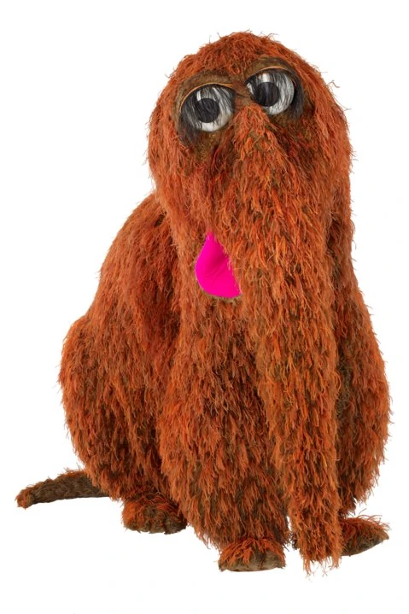
-women w/ those stupid eyelashes; cumbrellas
Snuffleupagus

Ezekiel 23:43 Then said I unto her that was old in adulteries, Will they now commit whoredoms with her, and she with them?

-a lady that is old that has been committing adultery

Ezekiel 23:44 Yet they went in unto her, as they go in unto a woman that playeth the harlot: so went they in unto Aholah and unto Aholibah, the lewd women.
Ezekiel 23:45 And the righteous men, they shall judge them after the manner of adulteresses, and after the manner of women that shed blood; because they are adulteresses, and blood is in their hands.

-By killing their babies; abortions

Ezekiel 23:46 For thus saith the Lord GOD; I will bring up a company upon them, and will give them to be removed and spoiled.
Ezekiel 23:47 And the company shall stone them with stones, and dispatch them with their swords; they shall slay their sons and their daughters, and burn up their houses with fire.
Ezekiel 23:48 Thus will I cause lewdness to cease out of the land, that all women may be taught not to do after your lewdness.
Ezekiel 23:49 And they shall recompense your lewdness upon you, and ye shall bear the sins of your idols: and ye shall know that I am the Lord GOD.

Exodus 20:14 Thou shalt not commit adultery.

-all of the laws about sex fall under this commandment

Deuteronomy 22:22 If a man be found lying with a woman married to an husband, then they shall both of them die, both the man that lay with the woman, and the woman: so shalt thou put away evil from Israel.

John 8:4 They say unto him, Master, this woman was taken in adultery, in the very act.
John 8:5 Now Moses in the law commanded us, that such should be stoned: but what sayest thou?
John 8:6 This they said, tempting him, that they might have to accuse him. But Jesus stooped down, and with his finger wrote on the ground, as though he heard them not.
John 8:7 So when they continued asking him, he lifted up himself, and said unto them, He that is without sin among you, let him first cast a stone at her.
John 8:8 And again he stooped down, and wrote on the ground.
John 8:9 And they which heard it, being convicted by their own conscience, went out one by one, beginning at the eldest, even unto the last: and Jesus was left alone, and the woman standing in the midst.
John 8:10 When Jesus had lifted up himself, and saw none but the woman, he said unto her, Woman, where are those thine accusers? hath no man condemned thee?
John 8:11 She said, No man, Lord. And Jesus said unto her, Neither do I condemn thee: go, and sin no more.

Job 31:1 I made a covenant with mine eyes; why then should I think upon a maid?

Job 31:9 If mine heart have been deceived by a woman, or if I have laid wait at my neighbour's door;
Job 31:10 Then let my wife grind unto another, and let others bow down upon her.

-if I commit adultery, then let my wife do the same
-oral sex

Matthew 5:27 Ye have heard that it was said by them of old time, Thou shalt not commit adultery:
Matthew 5:28 But I say unto you, That whosoever looketh on a woman to lust after her hath committed adultery with her already in his heart.

-this includes porn

2 Peter 2:13 And shall receive the reward of unrighteousness, as they that count it pleasure to riot in the day time. Spots they are and blemishes, sporting themselves with their own deceivings while they feast with you;
2 Peter 2:14 Having eyes full of adultery, and that cannot cease from sin; beguiling unstable souls: an heart they have exercised with covetous practices; cursed children:

Ecclesiasticus 18:30 Go not after thy lusts, but refrain thyself from thine appetites.

Ecclesiasticus 25:14 And any affliction, but the affliction from them that hate me: and any revenge, but the revenge of enemies.
Ecclesiasticus 25:15 There is no head above the head of a serpent; and there is no wrath above the wrath of an enemy.
Ecclesiasticus 25:16 I had rather dwell with a lion and a dragon, than to keep house with a wicked woman.

Proverbs 31:11 The heart of her husband doth safely trust in her, so that he shall have no need of spoil.

If you want a wife, but not sure what to pray for, use this scripture.

Ecclesiasticus 26:1 Blessed is the man that hath a virtuous wife, for the number of his days shall be double.
Ecclesiasticus 26:2 A virtuous woman rejoiceth her husband, and he shall fulfil the years of his life in peace.
Ecclesiasticus 26:3 A good wife is a good portion, which shall be given in the portion of them that fear the Lord.
Ecclesiasticus 26:4 Whether a man be rich or poor, if he have a good heart toward the Lord, he shall at all times rejoice with a cheerful countenance.

Hebrews 13:4 Marriage is honourable in all, and the bed undefiled: but whoremongers and adulterers God will judge.

1 Timothy 5:20 Them that sin rebuke before all, that others also may fear.

Proverbs 6:32 But whoso committeth adultery with a woman lacketh understanding: he that doeth it destroyeth his own soul.
Proverbs 6:33 A wound and dishonour shall he get; and his reproach shall not be wiped away.
Proverbs 6:34 For jealousy is the rage of a man: therefore he will not spare in the day of vengeance.
Proverbs 6:35 He will not regard any ransom; neither will he rest content, though thou givest many gifts.

