Event: Titus 2 Chat
Title: Two Become One Flesh
Hostess: Anna Israel, House of Bishop Yawasap
Date: Sunday, November 28, 2021

Mother Anna Israel
Mark 10:6 (KJV) But from the beginning of the creation God made them male and female.
Mark 10:7 (KJV) For this cause shall a man leave his father and mother, and cleave to his wife.
Mark 10:8 (KJV) And they twain shall be one flesh: so then they are no more twain, but one flesh.
• The man and the woman are to become one (with the same mind). Endure. Face your troubles and your trials. Some of you think that marriage is a game, but it's not. You will go through pain and pressure. Practice perseverance. Some of you are not practicing “S.P.A.” (study, pray, and apply). We have to read our four chapters, but most importantly, we have to apply! Reading does not do much if we do not apply. We must examine ourselves daily. Marriage is not 50/50. Marriage is a job. It takes work. Marriage is a career.

VIDEO - MARRIAGE IS WORK - SINBAD
https://www.youtube.com/watch?v=mPmH4ko7zhU
- A man wants a nurse to take care of him (you are that nurse).
- He wants you to pay attention to his health and know the signs and symptoms of sicknesses.

Mark 10:9 (KJV) What therefore God hath joined together, let not man put asunder.
- Woman means "of men."
- We look prettier when we are quiet!
- The tone that your husband uses, should not affect your reaction. He is a man. Men do not have to speak soft like a woman.
TO DO: | DO NOT DO:
be content with him | suck your teeth
make him feel welcomed in his own home | make faces
listen to him / pay attention to his needs | make smart remarks
be his nurse | give lip
rub his feet | nag
serve him like you would serve Christ | complain

Ephesians 5:24 (KJV)Therefore as the church is subject unto Christ, so let the wives be to their own husbands in everything.
- The Most high will bless us. He sees everything that you do, say, and think about your husband.
1 Corinthians 11:3 (KJV) But I would have you know, that the head of every man is Christ; and the head of the woman is the man; and the head of Christ is God.
- This is not hard to understand.
- It is plainly written.
- Your husband is your king and your boss.

Types of sisters with Jezebels spirits. These sisters can destroy their marriages.
Do not become this sister!
• Manipulator, deceitful, and controlling: all must go her way
• Prideful: never asks for forgiveness
• Abusive: rude and arrogant
• Selfish: only cares about money and benefits

VIDEO - More Weird Things All Couples Fight About https://www.youtube.com/watch?v=SRMXzq3bN_8
- Marriages will bring arguments; you will be annoyed, but stay in the spirit. As it is written (troubles in the flesh).

Amos 3:3 (KJV) Can two walk together, except they be agreed?
- Happy Husband, Happy Life!

Ecclesiasticus 25:1 (Apocrypha) In three things I was beautified, and stood up beautiful both before God and men: the unity of brethren, the love of neighbours, a man and a wife that agree together.
- Agreeing with your husband will make him happy.
- If our foremothers endured marriages, we can do it also.

1 Peter 3:1-4 (KJV)
1 Likewise, ye wives, be in subjection to your own husbands; that, if any obey not the word, they also may without the word be won by the conversation of the wives;
2 While they behold your chaste conversation coupled with fear.
3Whose adorning let it not be that outward adorning of plaiting the hair, and of wearing of gold, or of putting on of apparel;
4 But let it be the hidden man of the heart, in that which is not corruptible, even the ornament of a meek and quiet spirit, which is in the sight of God of great price.
• Obey him and listen to him. Your conversation should be humble, pure, and nice.
• A good conversation often makes his wallet open.
• Your beauty comes from within: honoring the Lord and the Most High. Looks fade away. God looks at your heart.
• Respect your Lord with the fear of God. God sees everything.
• Keep the fruits of the spirit. Keep charity, joy, peace, patience, kindness, long-suffering, gentleness, faith, modesty, self-control.

Ecclesiastes 4:9 (KJV) Two are better than one; because they have a good reward for their labour.
• A husband and a wife are a team!
- They agree together!
- You will get blessed together.
- Sometimes blessings do not come immediately, but they come.

Being a Godly wife:
• Are you practicing? Put the Most High first. Fear the Most High!
• Be submissive to your lord. Love him and be kind.
• Encourage and support him. Serve him and care for him. Be a pillar of rest. Be his help mate.
• Pray with him. Pray for him. Forgive him. Study with him.
• Be patient with him. Give him attention.
• Communicate with him. Say nice things. Ask him about his day. Build him up.
• Exhort him! Be his cheerleader.
• Satisfy with the 4 "S": Silence, Sandwich (food), Satisfaction, Submission.
- Do not nag him. Speak with soft words.

Proverbs 31:12 (KJV) She will do him good and not evil all the days of her life.
- You married him for a reason. Be good to him forever. Be a Godly woman with class! Learn your role. Stay in your lane. Marriage is work. In order to succeed, you need to win the race to get to the price. The price is the blessings from The Most High. Trust the Process! Marriage is Pain, Pressure and Perseverance.
- Be thankful. Say thank you.
- You are prettier when you are quiet and humble.
- You never know what you have until you lose it! You may have him now, but if he is gone, you will miss him. Then what will you do? Another sister will have him. Then, it will be too late.

Ecclesiasticus 26:2 (Apocrypha) A virtuous woman rejoiceth her husband, and he shall fulfil the years of his life in peace.
• Give him peace, not stress. Do not welcome him with arguments and claims. Give him space.

DO YOU RESPECT YOUR HUSBAND?
• Do not compare him with any other man.
• Speak comely. Say “please;” “thank you;" “I love you!"
• Do not call him names, ever! You will regret it!
• Do not correct him in public.
• Do not embarrass him.
• Do not start sentences with "You" because it is accusing.
• Do not discuss your marriage issues with other people.

Single sisters…
• Ask questions
• Ask people about him
• Prove him

Ecclesiasticus 6:7-8 (Apocrypha)
7 If thou wouldest get a friend, prove him first and be not hasty to credit him.
8 For some man is a friend for his own occasion, and will not abide in the day of thy trouble.
• Some men will get you pregnant or give you a sickness and leave you.
• Do not tell him your personal business.

Exodus 22:16 (KJV) And if a man entice a maid that is not betrothed, and lie with her, he shall surely endow her to be his wife.
• He will entice you with words and gifts. But when you sleep with each other you have to get married.
• Wait patiently. If that man is for you, The Most High will make sure you get together.

Matthew 26:41 (KJV) Watch and pray, that ye enter not into temptation: the spirit indeed is willing, but the flesh is weak.
- Sisters have so many complaints about their future husband, but he may be the one for you. Do not have unreasonable expectations. What do you expect? The perfect prince on a white horse?

VIDEO - DO YOU RESPECT YOUR HUSBAND?
https://www.youtube.com/watch?v=6leoNGVv5R0

VIDEO - DR. HEAVENLY SAYS BEAUTIFUL WOMEN HAVE UNREALISTIC EXPECTATIONS
https://banuaupdate.com/2021/10/30/licencie-relation-mentor-dr-heavenly-kimes-inspire-clients-avec-genuine-discuter-ce-qui-fait-mariages-final/
Be content about having the chief things in life: water, clothes, and a home.
The rest may not me necessary.
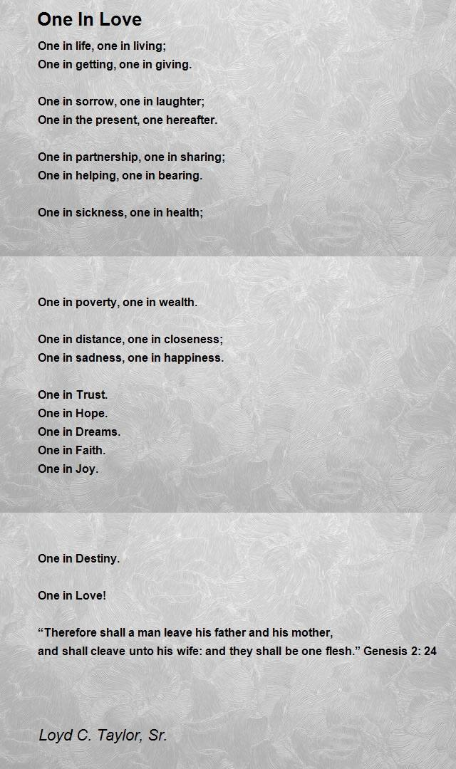

Most High in Christ Bless

