TITLE: Q&A Sorrow & Conception Pt.2
HOST: Azarayah Israel
DATE: Wednesday, June 8, 2022

Sister Azarayah

Article from Today, Health and Wellness: How this Black doctor is exposing the racist history of gynecology

The article is noting Doctor James Marion Sims known as the founder of gynecology, he earned this title through contributions made by experimenting on enslaved black women.

Psalms 83:3 (KJV) They have taken crafty counsel against thy people, and consulted against thy hidden ones.

Ecclesiasticus 12:10 (Apocrypha) Never trust thine enemy: for like as iron rusteth, so is his wickedness.

Never trust your enemy.

If you must leave your baby in the NICU (Neonatal Intensive Care Unit) *, stay there and watch your baby. *NICU is for babies that need extra care.

- They will vaccinate your babies.
- They will not give the baby your breast milk that the Most High gave us for healing, for pain relief, and for comfort.
- Stop putting trust in the healthcare system.

They were feeding my baby the formula that they give infants that are underweight, and she was struggling.

- I'm breastfeeding her and I had to always stay with her.

It takes about 2 or 3 days for our milk to come in so, sometimes we become engorged with milk.

Our bodies are trying to figure out supply and demand, how much milk goes out and our body determines how much it needs to produce.

A sister had a baby also in the NICU, she also had to stay there to ensure that her baby was given breast milk.

Vaccines for example. Depending on the type of insurance you have, and your race, is how they determine which vaccine they would give you. It is what they are told to give African Americans and people of color. They are not giving us quality vaccines even if we were to get vaccinated. That just goes to show they do not care about people of color.

They take those expired vaccines, and they send them to Africa and experiment on the babies over there.

Story: A sister said, “they tried to kill my son”. He was in NICU, they had him face down wrapped tight in a blanket. She said the Most High woke her out of her sleep, she went to see him, and the baby was fighting, trying not to suffocate.

These nurses make their rounds, and we are just a number to them, they do not love us.

Stop trusting in healthcare.
- Be mindful and keep watch over your babies.

Esau is nosy and feel entitled to say anything. My baby was 11 lbs 12 oz when she was born, and they wanted to know my birth story over and over.

- I just went through a traumatic experience. While in the NICU, I had a nurse look over my shoulder asking was my baby breathing?

- It took everything in me to stay in the spirit. I am holding her and watching her breathe. She was hooked to the machine and the nurse was just careless in how she was talking to me and about the situation. She was just trying to create a panic.

There was a nice edomite nurse. She took very good care of my baby. I was so weak but the way she cared for and handled my baby…wow!

- Now, she asked me first, but she bathed my baby.
- I could barely stand up to hold my own baby to wash her hair.
- I was so weak that I could not even hold my baby's head up.

And if you saw the video last week, I fell because I could barely walk, my hips were so unstable.

But she was such a wonderful nurse.

Proverbs 16:7 (KJV) When a man's ways please the LORD, he maketh even his enemies to be at peace with him.

Do not go to the hospital acting a fool, acting crazy and cussing people out. Use wisdom and be wise as a serpent.

The curses are real.

Deuteronomy 28:32 (KJV) Thy sons and thy daughters shall be given unto another people, and thine eyes shall look, and fail with longing for them all the day long: and there shall be no might in thine hand.

When you act a fool, they will call DHS (Department of Human Services) on you so quickly.

Make friends with the mammon (those in the world with wealth), be righteous.

Shared a video called: Ariah’s Lullaby: Her brothers and sisters told their story about her being born; something she can watch when she grows up.

Use wisdom when dealing with the medical system. There are different rights that we have that most people don't realize.

Birthing Person’s Rights
- The right to informed consent
- The right to refuse surgery or medical procedures
- The right to receive treatment when in labor or experiencing a medical emergency

Fetus’ Rights
- They will vary from state to state

Newborn’s Rights
- Parents will speak up for the child unless the state intervenes.
- They are very crafty at watching what you do and what you say, especially when it comes to vaccines.
  - They will find a reason why to intervene
  - Be very mindful of the words that you choose
    - We can lose control of our newborn.

Azaryah’s Labor Story

I went straight into active labor; total labor was under 2 hours.

A good chunk of that labor was pushing that baby out.

A question that a lot of people are afraid to ask is, “Did you tear”? No, I didn’t tear. And the reason why is because it was a very slow process.

My body was able to acclimate to the stretching.

Micro needling is a cosmetic procedure. It involves pricking the skin with tiny, sterilized needles.
- It creates more toned and tighter skin

When you have a baby, even if you don’t tear, you have microscopic skin tears that can’t be sewn up. It burns when you use the bathroom.

The Most High knew what he was doing when he designed our bodies.

- Some women experience skin laxity – a looseness of the skin after having a baby.
- Some women experience the inner lips of the vagina (the labia) are tighter after having a baby.
- It depends on the way that you heal.

So, for me personally, I am back to normal.

I had a miscarriage and had to have a D&C (D&C: Dilation and curettage is a procedure to remove tissue from inside your uterus). They held me open for like 30 min. My lord didn't notice anything. But a sister had the same procedure, and her lord accused her of committing adultery because it was different down there (note: the sister didn’t commit adultery).

That is the only time I can ever say I felt like something was off; it took a couple of months to feel normal.

If you are having issues with your pelvic area, go to a pelvic floor therapist. They will help you learn how to rebuild those muscles.

Sometimes, a therapist is needed for those areas, like incontinence. We women get to wound up. You need to know which exercises are good for you.

Video: Glute Bridge | Fitonomy App Community on Instagram

I would follow the exercises in this video every day.

- It helped to tighten my glutes (butt muscle)
- It helped to flatten my stomach
- It helped to tighten the back of my thighs
What do you do about Diastasis recti? (Diastasis recti is a common condition in pregnant and postpartum people. It occurs when the rectus abdominis muscles (six-pack ab muscles) separate during pregnancy from being stretched. The separation can make a person's belly stick out or bulge months or years postpartum).

It occurs after your pregnancy and certain exercises can make the condition worse. Avoid these exercises if you have a bulge in your stomach:

- Twisting movement (russian twist)
- Push ups
- Sit ups
- Planks
- Crunches

Postpartum stomachs where you can see the separation may cause problems, incontinence, pain, constipation, and nausea—especially those with unhealthy guts.

There are various looks of diastasis recti:
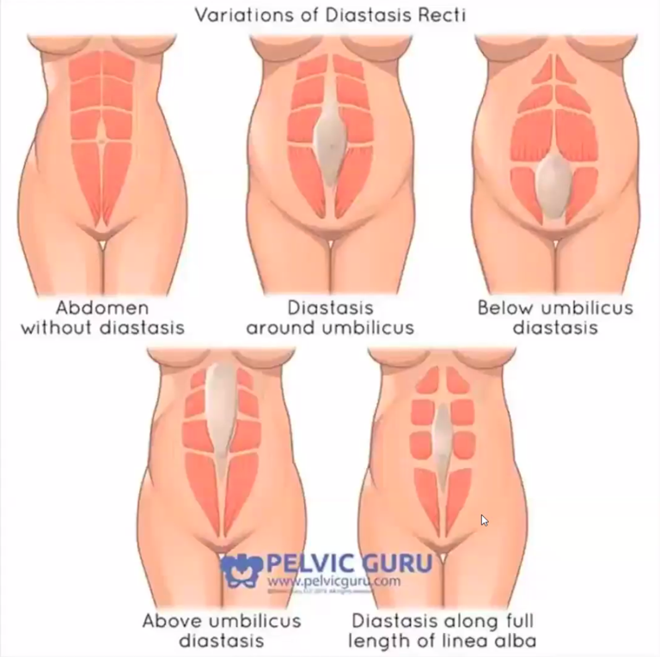

Stomach vacuum is the best exercise for diastasis recti.
- You pull the belly bottom to the back of your spine while you exhale; do repetitions of this exercise (holding it for as long as you can).
- It is not a strenuous exercise. You can try them right now or do them whenever you think of it.

Other exercises that are great for diastasis recti are:
- Squats
- Pelvic tilts
- Glute bridges
- Heel slides
- Cat cow
- Bird dog
- Kick backs
- Head lifts
- Lunges

A sister asked can you repair diastasis recti? Yes, the condition can be repaired; you don’t need surgery unless you have a severe case. Note: talk to your doctor.

- Look up online or Google ‘two finger test for diastasis recti’ to check if you have the condition.

Be patient. Don’t pressure yourself to snap back right after the baby because someone else did.
~ ~ ~
Shoulder Dystocia: Shoulder dystocia is a birth injury (also called birth trauma) that happens when one or both of a baby’s shoulders get stuck inside the mother’s pelvis during labor and birth. In most cases of shoulder dystocia, babies are born safely. But it can cause serious problems for both mom and baby.

- I suffered from this, and I had to work hard to push my baby out.

Most babies are delivered healthy however, there is a chance that the baby’s clavicle can be broken, or the arm or wrist. A nerve can be damaged in the spine if the neck is being pinched.

When the doctor tries to scare you about the baby being big, don’t be scared.

It is how you birth; it is taking your time pushing intuitively.

- Do your research
- Eat healthy
- Treat your body right
- Exercise

Gestational diabetes does cause larger babies.
~ ~ ~
Relationship with midwives

I opted for a hand-off delivery. My midwife allowed me to call her, she gave me advice all for now charge. She gave me a referral to go see an acupuncturist.

- If you have issues of being past, or the doctor is telling you that your baby is too big, or that they want to induce labor go see an acupuncturist for help.

If you pass your due date, it’s only an estimated due date, don't be afraid to go after that date. Trust the Most High and let your body work on its own.

Be patient and let that oxytocin flow; be calm.

I am unsure if you can do acupuncture if you have high blood pressure. You should do research and check with your doctor.

Question asked online: What do you recommend if you're group B strep positive?

Answer: You need antibiotics because you can give it to your baby.

It is a tricky situation, so consult first. Maybe your midwife can treat you but to have a free birth, unassisted at home, there is no way to get the medicine you will need and leave the hospital and go home to give birth.

The fire hydrant position or spinning babies will help you engage the baby into position. Find out how to do those positions and more or on YouTube.

Helpful tip: hire a doula.
~ ~ ~
Helpful Items to have for your birthing experience:

Frida Mom Instant Ice Maxi Pad
- Activate it and put it in your underwear.
- It relieves pains.
- It helps with tearing.
- Be mindful-if you have a 2nd or 3rd degree tear, don’t use the pads because the cold slows the healing process.
  - It is suggested to use witch hazel on a warm compress-consult with your doctor.

https://www.target.com/p/frida-mom-instant-ice-maxi-pad-8ct/-/A-76199077?ref=tgt_adv_XS000000&AFID=google_pla_df&fndsrc=tgtao&DFA=71700000012735142&CPNG=PLA_Baby%2BShopping_Local%7CBaby_Ecomm_Baby&adgroup=SC_Baby_Low%2BMargin&LID=700000001170770pgs&LNM=PR

https://www.amazon.com/dp/B07THDP4KZ?ref_=cm_sw_r_cp_ud_dp_NPZXDGWHD91CRWWST75G

Pangaea Wash, a feminine body wash Embrace Pangaea
- It is pricey but makes you feel clean if your pregnant and sweating more.
- If your pH is off, this will correct it.

Tea Tree Oil & Prebiotic Daily Feminine Wash
https://www.amazon.com/dp/B0072K2BMG?ref_=cm_sw_r_cp_ud_dp_57G5PWRE8DERPF3477B8

Tinctures

After birth tincture
https://belliestobabiesholistic.com/shop/fertility-pregnancy-postpartum/afterbirth-tincture/
- I used to prepare for postpartum hemorrhaging.
- It helps to release the placenta.
- It helps with after birth pains and cramps.

Gentle birth tincture
https://www.amazon.com/Mountain-Meadow-Herbs-Gentle-Birth/dp/B00LPJV6TY/ref=asc_df_B00LPJV6TY/?tag=hyprod-20&linkCode=df0&hvadid=309777797660&hvpos=&hvnetw=g&hvrand=1041706646064517812&hvpone=&hvptwo=&hvqmt=&hvdev=c&hvdvcmdl=&hvlocint=&hvlocphy=9016951&hv
- Take it 5-6 weeks before your due date.
- One major herb is red raspberry leaf.

Traditional Medicinals Organic Raspberry Leaf
- It helped me to have a painless pregnancy before

Last two helpful items are for postpartum shedding.

Floradix Iron supplement and Neocell + C pomegranate liquid Collagen
- Helps with hair growth.
- Helps with wrinkles.
- Couple these with your prenatal vitamins and a hair vitamin.

https://www.vitaminshoppe.com/p/flora-floradix-iron-herbs-8-5-fl-oz/fl-1007?mr:trackingCode=1C0F8296-0DBA-E911-8102-00505694403D&mr:referralID=NA&sourceType=sc&source=SHOP&acqsource=adlucent&store=467&gclid=CjwKCAjwkYGVBhArEiwA4sZLuKKLKjx5pSpR8gGdGd6MELfP

https://www.neocell.com/collagen-c.html?utm_source=google&utm_medium=shopping&utm_campaign=SCM%7CNEO%7CSmartShopping%7CBest&utm_content=140548967732&gclid=CjwKCAjwkYGVBhArEiwA4sZLuFKJNNGkZoTseS2GgFMD3besA_RR1akJGrOQd8MmmRiO0m0mi7fU9hoC-PUQAvD_BwE
~ ~ ~
CPR (Cardiopulmonary resuscitation)
Sisters were saying they wouldn’t know what to do if they labored and the baby wasn’t breathing.
- I suggest that everyone get CPR certified.
- You can an online certification at the National CPR Foundation.
https://www.nationalcprfoundation.com/?gclid=CjwKCAjwquWVBhBrEiwAt1KmwmT6cgTiGkg3-dWG-yK3o0HCZ4gYDm46qMxHRv5LxbRF2JOzpDanexoCHHcQAvD_BwE#

For sisters who may want a more hands-on experience, visit the Red Cross and schedule a class.
www.redcross.org
- When birthing at home, it will prepare you for the worse.
- It will give you instruction on basic life support, first aid, burns, chocking, torniquets, etc.
- They offer videos on most of these.

If someone else must give CPR to your baby, purchase a CPR mask as a preventative protection for your baby; germs and COVID-19.

You can take free CPR classes at the hospital.

The Red Cross and the American Heart Association CPR courses are great.
~ ~ ~
C-Section: Cesarean delivery: is used to deliver a baby through surgical incisions made in the abdomen and uterus.

Just because you have a c-section does not mean you have to continue to have them.
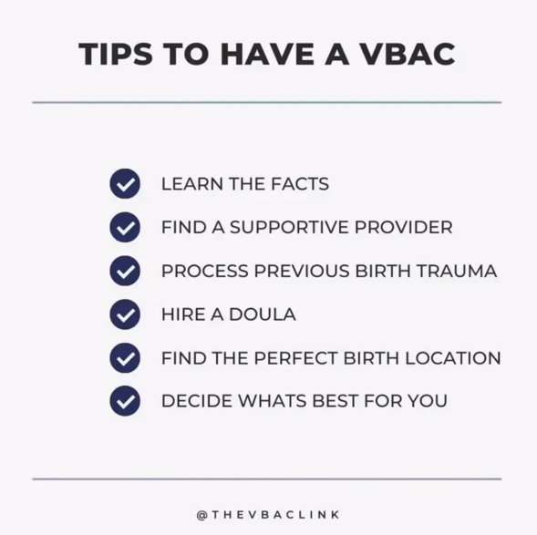

Trial Of Labor After Caesarean (TOLAC): you have the right to try a vaginal birth.
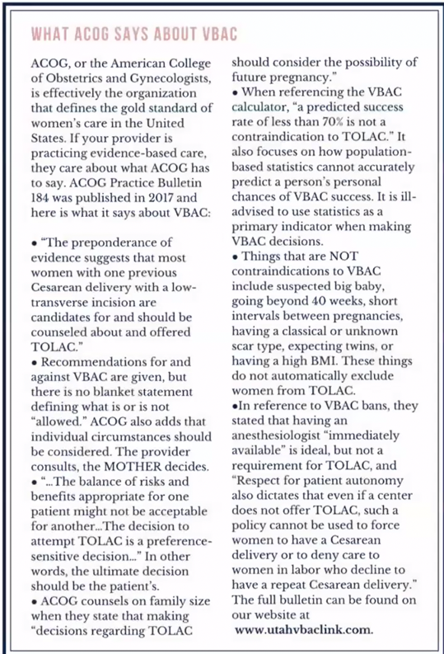
The doctors will pressure you to have a C-section. You have the right to try to have a normal labor.

Some statistics on Uterine Rupture:
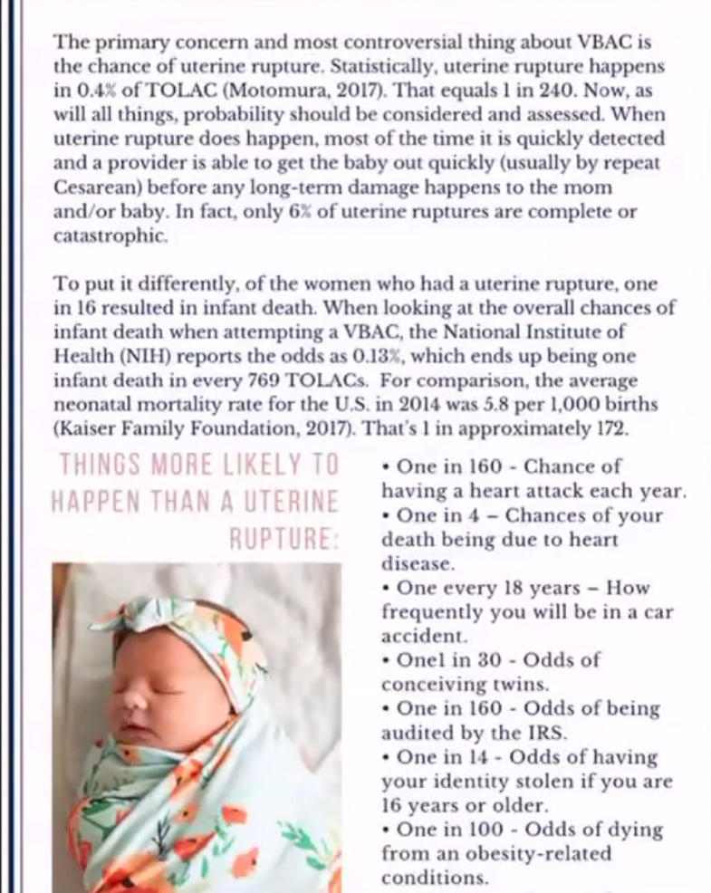

You have a greater chance of having a heart attack every year then your uterus rupturing.

I pray this article gives you some hope and encourages you.

Be mindful of your incision, it makes a difference on whether you can have a v-bac (vaginal birth after caesarean).
~ ~ ~
Sex

1 Corinthians 7:5 (KJV) Defraud ye not one the other, except it be with consent for a time, that ye may give yourselves to fasting and prayer; and come together again, that Satan tempt you not for your incontinency.

Anytime you decide you’re not going to not have sex; it must be agreed consent, like fasting and prayer.

Some sisters can go several months even years without sex. That is not good.

When you are not getting what you need, you lose self-control, now Satan is on you.

- I counselled a sister who said that sex is for the man and not for the woman; he gets his and I don’t get mine.

  - Some men deal with sexual misfunction, and they will respond with pride. They try to figure how to make the marriage work.
  - Communicate in a gentle way; tell him what your needs are.
  - Be patient and allow him to please you in other ways.

- Some sisters say they do not want oral pleasure.

There is a show on Netflix called, The Principles of Pleasure and watch the episode called, Our Bodies.
- A lot of times sisters do not know their bodies and how it works.
- If you haven’t achieved an orgasm, it is not necessarily the men.
- The describes the clitoris and what it does.

Be in tuned with your anatomy and how everything works.

Beware, the show describes using sexual toys which Israelites do not use; it is a form of idolatry when you have a husband who is capable.

- When you are not being pleasured, it could be something else.
- That is why communicating is important.

But, if you have communicated with your husband (communicated over and over), and he is not hearing you, and you are at the verge of committing adultery, get counsel.
- Let it be the last resort.
- Sometimes it will help, sometimes not because he has a health issue.

The above-mentioned show teaches that there are many paths to physical pleasure.

This is a common issue amongst the sisters. Here is another person that you all may want to seek out:

Shan Boodram on Instagram @shanboody (Shan Boodram is the Internet's most sought-after, certified sex educator, dating coach and relationship expert.)

Beware: you have to filter some of what she posts.

Please be patient and do not allow Satan to tempt you.
~ ~ ~

Two things I learned about postpartum hair shedding:

- 1) Onion water: use it as a pre-poo, saturate your hair, let it sit and then wash it out.
  - Apple cider vinegar will remove the smell.
  - Look it up on YouTube for a tutorial.
- 2) Clove water
  - Boil some water, soak the cloves, make a tea and spray your scalp.
~ ~ ~
When you have a low libido, try an herb called Maca Root.
- There are herbs that can help.

Sometimes men need supplement if they are not able to perform. But both parties can take some things to make it work between you.

Make it fun. Reinvent and rekindle with your lord.

The Q&A
Question: The hospital took my baby after birth alive and brought back a dead baby. What advice you have for mothers who may not have an outcome like yours or for sisters, on what steps we can take to prevent this outcome to the best of our abilities.

Answer: Do not let that baby leave your side. Do not trust the NICU. Have someone there to advocate for you if you are not in your right mind. Don’t be afraid to stand up to your doctor using wisdom. Always ask questions. Remember that the lord says, I kill, and I make alive.

Question: What is main scripture to apply concerning sorrow in marriage?

Answer: Find out what’s causing you to be sorrowful.

Ecclesiastes 9:9 (KJV) Live joyfully with the wife whom thou lovest all the days of the life of thy vanity, which he hath given thee under the sun, all the days of thy vanity: for that is thy portion in this life, and in thy labour which thou takest under the sun.

Life is short, the Lord is saying to live joyfully together. Anger is a choice; we chose to be angry. You can choose to be happy.

- If you’re the type of person who likes to nag all the time, you will drive your family crazy.
- Choose your battles.

Ecclesiasticus 19:1 (Apocrypha) A labouring man that is given to drunkenness shall not be rich: and he that contemneth small things shall fall by little and little.

Are you arguing about every little thing? Is this something that you can’t get over?

- Choose to be happy and don’t let the small things destroy your marriage.

Enjoy your marriage.

Question: How do I deal with the constant question of sisters asking, ‘when I am going to have a child’? I have explained briefly about the issues I am having. I try not to think about it, but it gets frustrating.

Answer: Sister are very sensitive about the subject of having babies, if you can’t.

Genesis 21:9 (KJV) And Sarah saw the son of Hagar the Egyptian, which she had born unto Abraham, mocking.

Sarah was barren and Hagar mocked her because she had a baby and Sarah was unable to bear a child.

Sisters think they are less than others or inadequate because they can’t bear a child. In all actuality, the Lord kills, and the Lord makes alive.

Deuteronomy 32:39 (KJV) See now that I, even I, am he, and there is no god with me: I kill, and I make alive; I wound, and I heal: neither is there any that can deliver out of my hand.

To answer your question, tell them Lord’s will. This is your cross and you have to bear. It something you will deal with so, stay in the spirit.

Question: I was recently pregnant with baby number 2, and I miscarried. Any advice on how to cope? It was hard to conceive, and I lost it again. It has been very hard. Any advice?

Answer: Think of Deuteronomy 32:39, it is the Most High’s will. I examined myself to make sure my life is aligning with the scriptures.

- Take the natural ginger root not the supplements during pregnancy.
- Give your body time to heal after miscarriage. It’s not a race.

Question: Is there a way to redo ‘Sorrow and Conception Pt. 1’?

Answer: Part one was condensed. A lot of this was in part one, I just showed more videos. Maybe in the future, I will.
~ ~ ~

Question: What about postpartum depression?

Answer: Your body needs to adjust. Check to see if your vitamin deficient. We are all short in vitamin D. Hang out some friends. Take a bath and pamper yourself. Sometimes, you just need a break. It looks like you are all together, when you are a mess. Sometimes you need a reset; like going out to eat with the sisters without the kids. Tell the kids to back off and set boundaries for yourself.

We are so obsessed with trying to appear perfect and life is not perfect.

You may evil thoughts about killing yourself or your baby.
- It is time to fast and pray. Satan is all in your head.
- It is time to get counsel.
- It may be time for you to get some medicine; seek the help of a physician.

Satan will get you when you are vulnerable, or deficient, drained and tired, and the baby is not going to sleep.

Endure and get help.

One sister on the panel said she had postpartum depression with her first baby.
- She was having thoughts of choking her lord and her baby.
- It was hard for her. Her baby was a good baby.
- She had no zeal to shower, clean or to cook dinner.
- She spoke to her doctor about what was happening to her.
- She was prescribed an anti-depressant. It did help her.
- She still had feelings; she wasn’t a zombie, but she didn’t feel like she wanted to hurt anybody.
- After a while, she was weaned from the anti-depressants.

It is not bad to feel sad or angry. We live in a society where we don’t want to feel.
- We don’t want to feel embarrassed.
- We don’t want to be corrected when we are wrong.

We put on a façade that we are all ok, while we are crumbling inside.
- We are thinking about taking our own life.
- We can’t do that. What about the laws? What about your husband and kids?
- If your husband remarries, the new wife may not take care of your children like you.

Question: How do you stay calm?

Answer: It’s a difference between a small and large baby. But whatever the weight, that is your baby, your threshold. What really helps me remain calm is the red raspberry leaf tea and gentle birth. Don’t take the two together. Stop taking the tea and begin with the gentle birth 5-6 weeks before you deliver.

When I felt the ring of fire, I was told to whisper instead of yelling.

- Hollering and screaming and crying goes against your body.

After you have baby, you experience the halo effect where you forget the pain you just went through.

Sing to yourself so you can refocus.

Red raspberry leaf tea helps me focus and it helps with the pain.

Question: Can birth tinctures help with hormonal balance and regulation of the menstrual cycle?

Answer: Cocoa Fresh, Sister Yoela can be better to answer that question; she an herbalist.

Question: Will we have sorrow in everything because of Eve?

Answer: No, not in everything.

Genesis 3:16 (KJV) Unto the woman he said, I will greatly multiply thy sorrow and thy conception; in sorrow thou shalt bring forth children; and thy desire shall be to thy husband, and he shall rule over thee.

Because of Eve he will greatly multiply our sorrow and our conception.

We experience joy and pain in life.

Question: If I have an unassisted birth at the house, when should I take the baby to the hospital and get him registered? I don’t want them (Esau) down my neck about it. I don’t really know much about how the process goes.

Answer: There are two different ways to go about having an unassisted birth. If there is no midwife there who is certified to do the birth certificate, then you can labor and have the baby and go to the hospital right away. You can get checked out, check the baby out and all the paperwork is done there at the hospital. It happens all the time. That’s the easy way.

The second way is, you labor and give birth, legally the baby must be seen at the hospital within 24 hours; check with your state; each state is different. Call your state’s health department and get the forms sent to you. You will have to have evidence of the pregnancy, a prenatal record from wherever you go get seen. You will have to have a statement from a physician or a license care provider that the baby was born alive and the evidence that the mother was present in that state.

Note: make sure it states that you had the baby at home. Esau tries to play games and say that you had the baby at the hospital for insurance purposes. NO.

Question: What is the wait time for twins?

Answer: Same as single birth. If it is twin boys, the wait time is 40 days. If it is twin girls, the wait time is 80 days. But if you have a boy and a girl, it is 80 days.

Question: Preeclampsia.

Answer: We didn’t really get to that. I know that people have a difficult time regulating their blood pressure. I am not very knowledgeable about that. I do know that some sisters have continue taking their medicine after. There are some natural remedies but I’m not sure if they will counteract with their regular medicine. I know magnesium helps and raspberry leaf tea.

The book is called, Healing After Birth. It has a lot of recipes to help with your nervous system and your moods; they have a spray – spray in your mouth or in the air, it will boost your mood.

Question: Can you eat placenta?

Answer: No.

Question: Can you make conditioner out of the placenta?

Answer: Yes, long you not eating it.

Question: How you increase connections in the congregation (the body)?

Answer: These relationships didn’t happen overnight. Prove a friend. Be patient. Be the friend that you want in others. Correct one another. Go over and above to show love to all your sisters. It takes time. You have to be in contact with other people; iron sharpeneth iron.

Don’t believe what you see on social media. Don’t compare your relationship to others.

Most High and Christ Bless

