Event: Titus 2
Title: Disrespect Disrupts Paradise
Hostess: Sister Bayla
Date: May 18, 2022

Sister Bayla

Outline

- Definition of disrespect
- Signs of a disrespectful wife
- Identifying disrespectful behavior patterns
- The value of your lord

I recommend the series that the Bishop did called, ‘The Hip Hop Marriage’.
- It is a good class where he talks about women coming out of the world and learning how to a submissive and loving wife.
- We have to kill that old woman.

We can’t bring ‘the world’ into the truth; those worldly attributes we learned about being in a relationship.

We are supposed to be focused on marriage being honorable and reverencing our husbands, that deep respect that they deserve.

We have hold ourselves accountable.

- We must acknowledge our errors, repent and give honor to our lords.

The men have been put in a place of dishonor in this captivity.

We have to remove the negative things we have learned in the world and re-learn how Israelite women should conduct ourselves according to the laws of the Most High.

- We have to be an example to our family that is not in the truth.
- We cannot have the mindset of an independent woman.

Sirach 26:14 (Apocrypha) A silent and loving woman is a gift of the Lord; and there is nothing so much worth as a mind well instructed.

Being silent and loving is a gift and not to be taken lightly.

We have to get ourselves together to be that gift for our lords.

- We have the commandments to ensure that we will be silent and loving, and to be respectful wife.
- We have to allow these scriptures to manifest in our lives.

1 Peter 3:10-11 (KJV) For he that will love life, and see good days, let him refrain his tongue from evil, and his lips that they speak no guile: [11] Let him eschew evil, and do good; let him seek peace, and ensue it.

We have to meditate on this scripture. We should want to have good days with our lords.

- Good days are going to come by watching what we say, reverencing him, and not disrespecting him.
- Refrain from evil by going railing for railing with him.

We have to do good, seek peace and ensue it.

We have to think about disrespect disrupting our paradise with our lords, ultimately paradise is the kingdom.

- Being disrespectful and rebellious is not the way to the kingdom.

We have to fulfill our role as an Israelite wife.

~ ~ ~

I want to talk about our foremother Eve and how her disrespect disrupted her paradise.

Question: How did foremother Eve disrespect her lord? [everyone in the chat can chime in]

Answers:

- Usurping authority
- Teaching him
- Disobeying him
- Idolatry
- By learning from another man
- Following other doctrines
- Being self-willed

Question: What was Eve’s job; what was she created for?

Answers: to be a help to Adam.

Tobit 8:16 (Apocrypha) Thou madest Adam, and gavest him Eve his wife for an helper and stay: of them came mankind: thou hast said, It is not good that man should be alone; let us make unto him an aid like unto himself.

Eve had a feminist spirit, she wanted to be equal to Adam.
- She wanted the power that he had.

Sisters still deal with the Eve spirit, and we have to understand the consequences of her actions.

Wisdom of Solomon 2:23 (Apocrypha) For God created man to be immortal, and made him to be an image of his own eternity.

Adam and Eve were in the garden of Eden, their paradise. They were immortal.

- We want immortality and eternal life.
- We want that paradise, the kingdom.

It says in the next verse, envy of the devil came death into the world.

- We have to have the mindset that Eve had paradise and immortality.
- We should check ourselves; check our spirit.
- The Eve spirit can come upon us at any time.

The scripture says counsel before every enterprise. Married sisters, your lord is your first counselor.

Eve was created to be a helper and a stay.

- We are created to help our lords, to raise the children and to do our wifely duties.
- We cannot usurp authority over our lords.
  - That is being disrespectful.
- That disrupts our chance at paradise.
- Being disrespectful and trying to compete with him causes confusion.

This is a serious problem with Sisters.

The men are going out doing the work of the Lord. Anything can happen to them.
- Are we checking our spirit?
- Are we really giving them the reverence that they need?
- Can he safely trust in you?
- Are we going to do what you are supposed to do?

  - Go to Sabbath class.
  - Put in works in the body.
  - Take care of his children.
  - Reverence him.

Ask yourself, do you really believe?

Do you see your lord as one of the principled men?

Here is a scripture that shows the consequences of Eve’s disrespect towards her lord.

Genesis 3:17-19 (KJV) And unto Adam he said, Because thou hast hearkened unto the voice of thy wife, and hast eaten of the tree, of which I commanded thee, saying, Thou shalt not eat of it: cursed is the ground for thy sake; in sorrow shalt thou eat of it all the days of thy life; [18] Thorns also and thistles shall it bring forth to thee; and thou shalt eat the herb of the field; [19] In the sweat of thy face shalt thou eat bread, till thou return unto the ground; for out of it wast thou taken: for dust thou art, and unto dust shalt thou return.

Adam went from naming the animals in the earth to having to work. Death came into the earth from Eve not hearkening to the commandments of the Most High.

- Think of that before we let any evil come out of our mouths.
- There are consequences that come with being disrespectful.
- We will not get the kingdom, paradise.

Sister Yemina

I will use my own personal story of what not to do. I had a Michal spirit; it resonates with me.

1 Samuel 18:27-28 (KJV) Wherefore David arose and went, he and his men, and slew of the Philistines two hundred men; and David brought their foreskins, and they gave them in full tale to the king, that he might be the king's son in law. And Saul gave him Michal his daughter to wife. [28] And Saul saw and knew that the LORD was with David, and that Michal Saul's daughter loved him.

Saul was the king of Israel who loved David but then ended up despising him. He decided to give his daughter, Michal to David to be his wife.

Read 1 Samuel 19:11-17 (KJV) Saul wanted to kill David. Michal went against her father and helped David escape. Saul asked her why she helped David, and she said because David was going to kill her if she didn’t.

Read also 1 Samuel 25 (KJV) and 2 Samuel 3 KJV) to gain understanding of David and Michal.

David asked for Michal.

- Our lords chose us to be with forever, until Christ returns, after he was told he could never have anyone else. We cannot disrespect them.

- They are learning how to be husbands just like we are learning to be wives.

2 Samuel 6:16, 19-23 (KJV) And as the ark of the LORD came into the city of David, Michal Saul's daughter looked through a window, and saw king David leaping and dancing before the LORD; and she despised him in her heart. [19] And he dealt among all the people, even among the whole multitude of Israel, as well to the women as men, to every one a cake of bread, and a good piece of flesh, and a flagon of wine. So all the people departed every one to his house. [20] Then David returned to bless his household. And Michal the daughter of Saul came out to meet David, and said, How glorious was the king of Israel to day, who uncovered himself to day in the eyes of the handmaids of his servants, as one of the vain fellows shamelessly uncovereth himself! [21] And David said unto Michal, It was before the LORD, which chose me before thy father, and before all his house, to appoint me ruler over the people of the LORD, over Israel: therefore will I play before the LORD. [22] And I will yet be more vile than thus, and will be base in mine own sight: and of the maidservants which thou hast spoken of, of them shall I be had in honour. [23] Therefore Michal the daughter of Saul had no child unto the day of her death.

Michal hated David.

- How many times have we all seen our lords in the spirit having fun, and we bring negativity with our big mouths?
- We were being disrespectful to him.

The Most High chose David over her wicked father. I am going to rejoice, and I am going to be happy.

Michal’s paradise is gone, it’s shattered; it is disrupted because of her mouth.

- All she can do is sit and watch as he enjoys himself with other women.
- He is still praising the Lord.
- All she had to do is keep her mouth shut.

This story reminds me of how I treated my lord.

- Early in the truth, every time my lord was getting ready to walk out of the door to go to camp, I wanted to talk to him about something stupid.
- I did this for about 4 weeks of Sabbaths, when he looked at me and said, “you always do this”.
  - He said that I always have something negative to say right before he leaves for camp.
  - He said his spirit is supposed to be right for camp and he left.
- I could not say anything.
- I had a habit of disrespecting my lord any time he was going off to do something he enjoyed.
  - He got up in my face and he was mad.
- I sat there the hold day.
- I said that I have to fix this. He’s right.
- I began to examine myself and I fixed it from that day forth.
- Now, when he leaves, I tell him to BRING IT OUT!!!

I wanted to tell yawl to stay in the spirit.

Do not ruin your lord’s fun.

Once you realize what you are doing, fix things and correct your behaviors.

~ ~ ~

Sister Bayla

A lot of sisters have those same stories when they first come into the truth.

Our men are going up to build up the nation of Israel so we can get out of this captivity.

- We mad, bringing up bills with the screw face.
- He doesn’t want to hear that.
- We have to focus on our jobs.
- Let’s do things to uplift our lords; like send him a little text message honoring and reverencing him.
- Don’t quench his spirit.

A quote from Bishop Nathanyel: Marriage is the foundation for nation building.

When we think about nation building, we have to make sure our marriage is right.

We women have to be accountable.

- He is telling you something that you will need to learn and grow.
- They are our heads of protection.
- He is building you up in this truth. Allow him to do that.
- Allow him to command his household. Give him the respect he deserves.

The definition of disrespect is the low regard or esteem for someone or something, a lack of respect.

The definition of respect is a feeling of deep admiration for someone.

- Being disrespectful is rude behavior.
- Our goal is to be heirs together with our lords.

Video: https://www.youtube.com/watch?v=68P2hyJYjpI
Shahrazad Ali – The Blackman’s Guide to Understanding the Black woman
“…the black woman’s disrespect and rebellion against the leadership and the authority of the black man is the direct cause of the breakdown in our black family structure.”

I am going to re-word it so that we can understand…

- The Israelite woman’s disrespect and rebellion against the leadership and the authority of the Israelite man is the direct cause of the breakdown in the Israelite family structure.

Question: How many sisters agree with this quote?

Answers: I am seeing a lot of sisters do agree in the chat.

All praises for holding ourselves accountable.

Though the sister is speaking from a worldly standpoint, what she was saying is spiritual.

- You have to meditate on that.
- Apply what she said to your spiritual walk.

We cannot have disrespect and rebellion for our lords or even for the leadership that the Most High set up to guide us.

- It causes the family structure to suffer.
- We are supposed to be building ourselves up to be the Proverbs 31 women.
- We are trying to walk righteously; we are trying to be a pillar and a help meet for our lords.
- We have got to kill that carnal woman.

When we disrespect, we are walking in the flesh, not in the spirit.

- We have to understand the magnitude of this.

Our children are watching us. They will see how we interact with our lords.

- We have to show our children a righteous example.
- We show them a respectful example.
- We have to teach our daughters how to behave and our sons what a righteous woman looks like.

Our kids are exposed to social media, for example, we have to be a greater example.

Ask yourself if you are doing what you are supposed to do by being that example?

We see perilous times coming, it is not time for play.

We cannot allow our disrespect to disrupt what we are trying to get, the kingdom (paradise).

It is time for us to be accountable.

Our lords are the prize and we should all be thankful for that.

It is time to renew our minds and show our children how to respect our lords and be the Israelite women that the Most High said we should be.

- We were not taught how to act in the world.
- Now, that we know better, we have to do better.

Let’s go into some signs of identifying disrespectful behavior.

We try to play like we were not being disrespectful but in fact, we know exactly how we were acting.

- Coming into the truth is like going to the hospital, we are sick and we have a lot to work on.

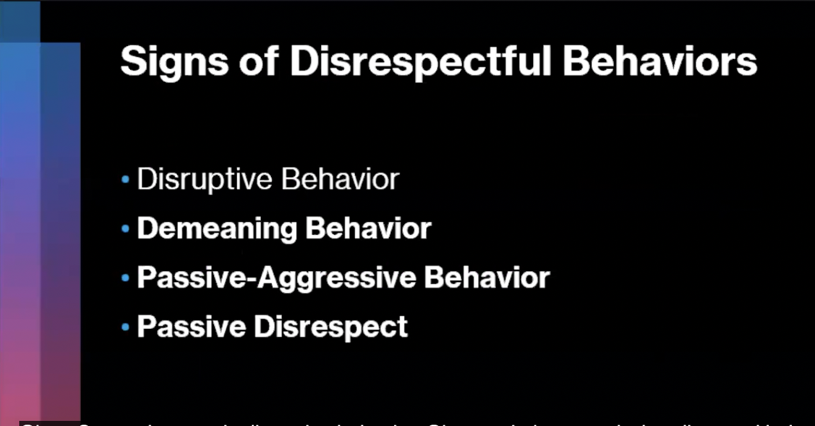

- Disruptive Behavior

- Temper tantrums
- Physical aggression
- Anger
- Rude outburst
- Verbal threats
- Swearing
- Pushing
- Throwing objects
- Bullying

Sisters are probably saying that we have repented; we don’t those things. Well, we have to go back to the basics and check our spirits.

- We have to examine ourselves fully.
- Tear yourself down and build yourself back with these scriptures.
- The scriptures say, “know you not your own selves”.

You know if your behavior is disruptive.

- You are mad on the feast day, for example, and you sit out in the car keeping yourself away from everyone.
- That’s disruptive when the Most High says to keep the feast with joyfulness and gladness.

- Demeaning Behavior

- Making demeaning comments
- Having spiteful behavior
- Backstabbing
- Having a lack of respect

Your lord gets a promotion, and you act like whatever because it’s going to be more work for him and more time that he’s going to be away from your family.

- You are selfishly thinking of that rather than thinking about what an honor for him to be promoted by the Lord.
- You are not trying to be his cheerleader but the opposite.

- Passive-Aggressive Behavior

- Refusal to do tasks (your lord may command you to get the pantry together, make sure his home is nice and neat, or for you to get up at a certain time).
- We are stubborn about the things asked of you.
- We deliberately delay responding to calls.
- We undermine his position, status, or value.

We don’t like for our lords to tell us anything.

We don’t properly communicate.

- He may send a message saying to do something and we will just act like we don’t see the message, knowing we did see it.
- This is a form of disrespect.

- Passive Disrespect

- Chronic lateness
- Sluggish response to requests
- A procrastinator
- We are never prepared

As a help meet, we have to be prepared.

- Passover prep
- Sabbath prep
- Going out-of-town events
- Tabernacles
- Removing the leaven for the Passover

We like to wait until the morning or even the day before to get things together.

- We figure that we have time but your lord told you two weeks ago to start getting things together.

We cannot move like that anymore, Sisters.

These things are a form of disrespect towards our lords.

We have to ensure that we are being a pillar of rest for them; that your lord knows that you have this.

- We are going to be at the Sabbath on time.
- We are going to show up at the feast days.
- We are going to spend time with the senior sisters more.
- We are going to study more.
- We are going to be on time.
- We are going to be attending the Titus 2 chat.
- We will be in the spirit.
- And, we will hold ourselves accountable.
- We will do whatever it takes to make things easier for him. We got it covered.

~ ~ ~
We are going to go into the signs of a disrespectful wife.

Video: IUIC | Satan’s Desire to Destroy Your Marriage: Are You the Problem?
https://www.youtube.com/watch?v=liQfPnuEeso

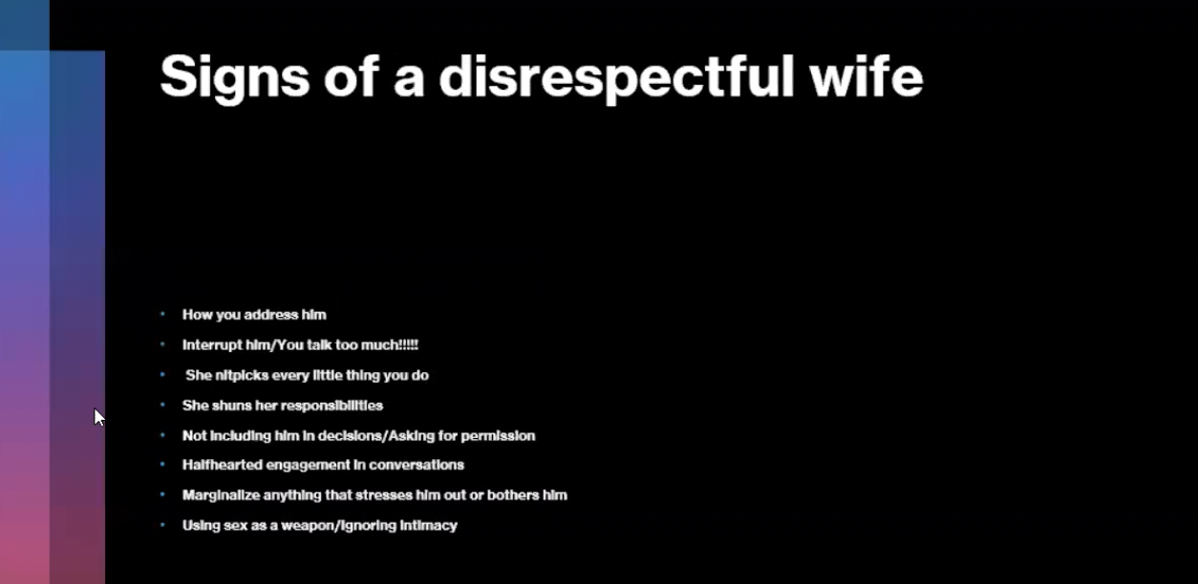

Sign #1: The way we address our lords.

- We don’t believe, bottom line.
- This is very disrespectful.
- Your lord has changed his name and we want to remind him of that simple man he used to be.
- Why do we call him by his worldly name?
  - Are you hoping that he goes back to being Tyrone so you both can be out of the truth and back in the world?
- Our actions do not show that we see our lords as one of the “principle men”.

Sign #2: We interrupt him and talk too much.

- One of the quickest ways we can be disrespectful is by interrupting him in his speech.
- We do not care about what he is saying; we just want to make a rebuttal.
- It shows that we are selfish preventing open communication.

Sirach 11:8 (Apocrypha) Answer not before thou hast heard the cause: neither interrupt men in the midst of their talk.

- Especially during correction time, we are never to interrupt our lords while speaking.
Sign #3: We nitpick at every little thing he does.

- An endless stream of criticism from us is not a good sign that we respect him.
- We pull him apart at the seams about every little thing that annoys us or things he does wrong.
- Nothing this man does is right (so we think).
- This is a damaging and disrespectful habit.

When we are being corrected, it’s not about him.

- We bring up things he does.
- This is about us (you).

Take the correction and grow from it.

- Are we being accountable?
- Are we actively listening?

We cannot tear our lords down for trying to provide for the family and still push this truth.

We should be that pillar of rest. We have to do all that we can to support him.

When that spirit of disrespect comes on us, we must catch it and recognize; that spirit will disrupt our paradise.

- Focus on the goal and see how you can help him achieve it.

Have the mindset that we will be his cheerleader and not his oppressor.

Sign #4: We shun our responsibilities.

- A disrespectful wife will not make any effort to take care of the things commanded by her lord.
- We will cook up some defense to get out of our responsibilities.
- We make time for social media and not the things our lords told us to do.

We have to make time to do the things he asks. It brings peace to the house when we are submissive and we listen to what our lords say.

Sign #5: We do not include him in decisions or we do not ask him for permission.

- We may go shopping or out to eat without letting him know.
- We have to ask him first.
- We are telling him that we do not value his opinion; that’s the independent mindset.
  - The independent mindset is not for Israelite women.
Sign #6: We have half-hearted engagement in conversations.

- We are not paying attention to what he has to say.
- We should be attentive and listen when he talks.

Sign #7: We marginalize (belittle) anything that bothers him.

- We don’t want him to think that their feelings don’t matter.
- We have to be that loving wife. If he is stressed, do this instead:

  - Give him a foot rub
  - Give him a massage
  - We will do whatever to make him feel better.
  - This is our time to support him and be a help meet.

Sign #8: We use sex as a weapon; we ignore intimacy.

- We get angry with our lords so we tell them we are “not in the mood”.
- We have to follow what the scriptures say.

1 Corinthians 7:4-5 (KJV) The wife hath not power of her own body, but the husband: and likewise also the husband hath not power of his own body, but the wife. [5] Defraud ye not one the other, except it be with consent for a time, that ye may give yourselves to fasting and prayer; and come together again, that Satan tempt you not for your incontinency.

- Intimacy plays a huge role in marriage.
- Captivity is stressful; he may need a release.

We have to put on a different mindset in this truth.

We have to kill everything that we learned in the world; it was not of God.

We have to renew our minds and focus on him.

Romans 12:2 (KJV) And be not conformed to this world: but be ye transformed by the renewing of your mind, that ye may prove what is that good, and acceptable, and perfect, will of God.

The Israelite women have to be completely different from those in the world.

We have to keep the laws at all times, especially in our lord’s home.

We have to give our lords the respect they deserve or else we will not see the kingdom.

Genesis 2:21 (KJV) And the LORD God caused a deep sleep to fall upon Adam, and he slept: and he took one of his ribs, and closed up the flesh instead thereof; [22] And the rib, which the LORD God had taken from man, made he a woman, and brought her unto the man. [23] And Adam said, This is now bone of my bones, and flesh of my flesh: she shall be called Woman, because she was taken out of Man. [24] Therefore shall a man leave his father and his mother, and shall cleave unto his wife: and they shall be one flesh.

We have the nerve to want to disrespect our lords.

We have to go to stop.

No man wants to cleave on to a disrespectful and rebellious woman.

We have to focus on the things we say and our actions.

Sister Shamara

Disrespect definitely does disrupt the peace in our homes.

A man of the Lord will not stand by and allow a woman to disrespect him.

- There will be no paradise in the home.

I have done everything on the list of signs of a disrespectful woman during my lifetime.

We have to change through the application of the scriptures.

We can transform ourselves from being disobedient, and disrespectful to submissive, honorable, and virtuous women by applying the scriptures.

When I am being corrected by my lord for something, in my head I’m thinking of the scripture, Ephesians 5:33.

To become heirs together with your lord, how can someone else hold you accountable when we are not holding ourselves accountable.

Ephesians 5:31-33 (KJV) For this cause shall a man leave his father and mother, and shall be joined unto his wife, and they two shall be one flesh. [32] This is a great mystery: but I speak concerning Christ and the church. [33] Nevertheless let every one of you in particular so love his wife even as himself; and the wife see that she reverence her husband.

Marriage is a representation of Christ being married to the nation of Israel.

Israel is hard-headed and rebellious; I understand, Eve. I know where the rebellion was coming from.

If we can’t get ourselves together as women, how are the men supposed to lead when the foundation of the man leading the nation of Israel starts in his own home?

- We are not allowing him to be the leader that the Most High called him to be.

We understand in verse 33 that the man should love his wife, but we are commanded to reverence him.

- When we do not reverence him, we are breaking God’s commandment.

When we do what we are supposed to do, the men will graciously do what the Lord commanded them to do.

- We make it difficult for ourselves in our rebellion and disobedience rather than keeping the commandments of God.

We need to be our lord’s number one cheerleader.

We have got to be an advocate for our lords at all levels, spiritually, physically, and emotionally.

Satan is out to destroy marriages.

John 21:15-17 (KJV) So when they had dined, Jesus saith to Simon Peter, Simon, son of Jonas, lovest thou me more than these? He saith unto him, Yea, Lord; thou knowest that I love thee. He saith unto him, Feed my lambs. [16] He saith to him again the second time, Simon, son of Jonas, lovest thou me? He saith unto him, Yea, Lord; thou knowest that I love thee. He saith unto him, Feed my sheep. [17] He saith unto him the third time, Simon, son of Jonas, lovest thou me? Peter was grieved because he said unto him the third time, Lovest thou me? And he said unto him, Lord, thou knowest all things; thou knowest that I love thee. Jesus saith unto him, Feed my sheep.

Feed my sheep. Go out and get the other brothers (the unrepented) to get their houses in order so that the nation of Israel can repent until Christ comes. That is the goal.

Eve disrespected her lord and lost paradise. Don’t lose the paradise in your lord’s home.

ALL PRAISES TO THE MOST HIGH. MOST HIGH AND CHRIST BLESS.

