Topic: Baby Prepping for the Hospital & Home
Host: Mama Mehidah (HO Deacon Eythan) - PA
Event: Titus 2 Chat
Date: 4 May 2022
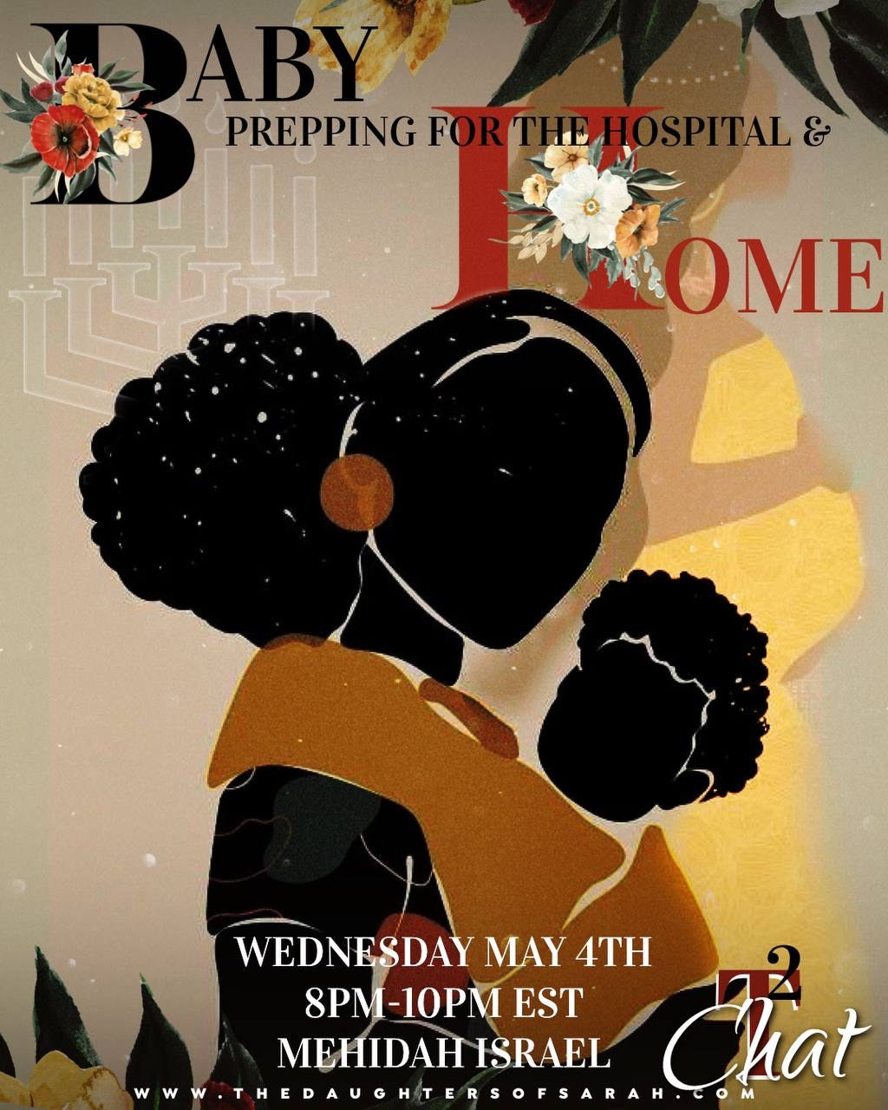
Shalom everyone,
Tonight, we will be discussing prepping for your baby to be delivered at a birthing center, hospital or at home.

Mothers Quiz:
- The mother with the seven sons can be found in the book of ________________.
  - II Chronicles
  - II Maccabees
  - II Kings
  - None of the above.
- True or False. It was known for women to nurse for three years. True.
- Samuel’s mother was
  - Esha
  - Sarah
  - Hannah
  - Willow
- True or False. Hagar is one of the twelve tribes of Israel’s foremothers. False.
  - Bonus Question: Who was Hagar? She was Ishmeal’s mother and Sarah’s maidservant.
- True or False. The nation of Israel has five foremothers. True - Leah, Rachel, Bilhah, Zilpah, & Asenath .
- True or False. Susanna did not have children. False. See History of Susanna 1:30 KJV So she came with her father and mother, her children, and all her kindred..
- The Most High opened Sarah’s womb and blessed her with a son named
  - Ishmael
  - Isaac
  - Issachar
  - Ish
- Bonus Questions: What does Isaac mean? One who laughs. Why was he named Isaac? Sarah laughed at the thought of giving birth at an old age.

Pregnancy Questions:
- How many of you are pregnant right now?
  - There are currently 12 sisters pregnant in the Philadelphia congregation. We are fruitful Philly! We are examples of us multiplying in the times of our affliction.
- Post an emoji or state the size of your belly. 🍋🥥🍓🍌🍎
- Is this your first time being pregnant?
- During your pregnancy what are your go-to’s that bring you joy?
  - I love going to Wa-Wa’s for their ice. It is like snow!
  - Examples: Smothers potatoes & onions, freezer ice, mango with pepper, dressing up to go to bed.
- How many of you have or want to deliver in the hospital? Birthing center? Home?
- How many of you believed that your fertility dropped after the age of 35 or older?
  - I heard that your biological clock decreases after your 20’s all my life. Someone lied! Lord’s will, I will be having my third child by 8/2022 after the age of 35.
Congratulations to all the mothers that are currently expecting!

Genesis 16:2 KJV
2 And Sarai said unto Abram, Behold now, the LORD hath restrained me from bearing: I pray thee, go in unto my maid; it may be that I may obtain children by her. And Abram hearkened to the voice of Sarai.
- Sarai recognized that she was barren at the time and allowed Hagar to bring forth seed for Abraham.
Genesis 20:18 KJV
18 For the LORD had fast closed up all the wombs of the house of Abimelech, because of Sarah Abraham's wife.
- Why did the Lord close the wombs of women in the house of Abimelech? King Abimelech did not know that Sarai was Abraham’s wife due to him saying that she was his sister.
Genesis 18:9,10 KJV
9 And they said unto him, Where is Sarah thy wife? And he said, Behold, in the tent.
10 And he said, I will certainly return unto thee according to the time of life; and, lo, Sarah thy wife shall have a son. And Sarah heard it in the tent door, which was behind him.
Genesis 21:1,2 KJV
1 And the LORD visited Sarah as he had said, and the LORD did unto Sarah as he had spoken.
2 For Sarah conceived, and bare Abraham a son in his old age, at the set time of which God had spoken to him.
- When you become pregnant and conceive, there is an angel of the Lord visiting you.

In the Prepartum Setting

Do not neglect your prenatal appointments especially if you are over the age of 35 years old. It can become overwhelming being bombarded with appointments from once a month, every 2 weeks, to every week. Do Not Miss Your Appointments.

- Advise your sister to attend all of her appointments. You can be diagnosed with preeclampsia which is very dangerous for you and your baby. I had this during my first pregnancy and was treated with low-dose aspirin to lower your risk. If your urine appears foamy like beer, go to the doctors for evaluation! If you experience edema or any symptoms outside of the ordinary, go to the doctors.
Every pregnancy and delivery is different.
- For your first pregnancy you may have started to show at 5 months, but with your ninth child you may show earlier at a few months.
- Do not make rude remarks (e.g Why are you this big/ showing so soon?). Do not touch a pregnant woman’s stomach if you are not close to them or have their permission.
- Make sure you drink your water.
In preparation for your delivery, take advantage of all outlets available.
- You do not have to be a superwoman. Your body will tell you to lay down; do not overexert yourself.
- No one has to be as ‘strong’ as the black woman. When the other nations seek help, no one sees them as weak.
- If you are able to go see a chiropractor, do so to remove some issues you are having. Utilize Sister Doc in Atlanta, GA or ask if she has any references in your area.
- Utilize delivery services such as Walmart Delivery. You can add items to your cart if you forget to do so earlier. If you have the funds, try HelloFresh or other meal kit services.
- Have your parents or in-laws help with the children if they are respectful.
- Have other sisters in the body that you trust help you.
- Teach your children at a young age to do chores, so they can help with activities like the laundry. Pay attention to the skills that each of your children have and have them work on that.
  - E.g. If your child is good at organizing, have them organize items in the home. My daughter loves to bake, so I am able to utilize her in the kitchen.

Proverbs 31:27 KJV
27 She looketh well to the ways of her household, and eateth not the bread of idleness.

- Being pregnant is not an excuse to be idle. If you have other children, you have to consider your husband in the postpartum setting.
  - This is not pertaining to sexually. If you give birth to a man child, you are unclean for 40 days. You are unclean for 80 days if you give birth to a daughter.
  - If you are pregnant with twins (e.g. a boy and a girl), you are still unclean for 80 days because of birthing a daughter. If you have twin boys, you are unclean for 40 days.
  - If you had to have a medical intervention for a miscarriage, you can not factor in how long you will be hemorrhaging for. You are unclean until your bleeding ceases if you miscarriage unfortunately.
- You have to consider your older and younger children.
  - E.g. Irish twins are babies that are born in the same year (less than 12 months apart).
  - There is a lot to factor in. Do they have healthy food to eat? Are you still nursing your one year old and your newborn? Will you be nursing twins?
    - You are capable of nursing multiple children. It is possible.
- If you become overwhelmed, speak up and say something.

Creating a Birthing Plan

How many of you have a birthing plan if you plan on delivering at a birthing center?
- It is okay if you did not know about this until after having a few children.
- Find out if there are sisters near you that know how to develop birthing plans or you can find someone online.
- You can locate birthing centers located near you by searching online. Seek sisters that are knowledgeable in finding good birthing centers near you.
- When I created my birthing plan, my doctor called it ‘cute.’ Many physicians do not expect us to know about these things.
- You can also hire a doula. There are some sisters in various states that are doulas.
  - Sis Tabitha is knowledgeable as a midwife and is based in Texas. Sister Yoela from the house of Deacon Isaac is also a doula. If there are no doulas in your congregation, someone may be able to refer you to one.

There are certain items that you may want to have packed for a hospital delivery. Start packing your bag early.
- Nightgown with nursing accessibility.
- Comfortable slippers.
- Lip balm.
- Hair Ties.
- 4 Solid air fresheners or oil diffusers
  - The hospital smell is unpleasant and candles are considered fire hazards.
- Personal toiletries - toothbrush, toothpaste, etc.
- Bible. Notebook. Pens. Tablets, iPad, chargers, etc.
- Pack items for your Lord as well.
- Extra empty bag
  - To take the comb, brush, blanket & diapers that are provided for your baby. Your insurance covers this!
- Regular clothes.
  - I personally can not stay in a hospital gown all the time. Get up and get dressed.
- Get your nails done and hair a month in advance.
  - The staff will talk about your presentation. I gave birth a month in advance with my feet undone and my hair was not ready. My Lord had to bring a comb from home and help detangle my hair.
  - You may want to keep your head wrapped, but listen when I say, “It Gets Hot!” I am warning you to get it together now.

Home Delivery Items:
- Put a fitted sheet down and a waterproof material with another fitted sheet on top.
- You do not want to give birth on a plastic sheet, as this is very uncomfortable.

Mama Azaryah HO Deacon Abbayael: [Story time]
I had a miserable experience with my first birth at the hospital. I had a rude nurse. I felt like I had no control over my body, received an epidural, and experienced lightning crotch. Whenever I had a contraction, it felt like someone was stabbing me with an ice-pick in my vagina. They kept telling me that I was not supposed to feel any pain since I had received an epidural. I was miserable and they would not let me get up to use the restroom. Mind you, I was induced two weeks early and had not received Pitocin.
Fast forward to my second birth experience, I had a midwife with me at the hospital. I enjoyed the experience and I wanted to try this at home. For my next child, I was able to try an at home birth which was covered by my insurance in Florida at the time. It was an amazing experience. You are in the comfort of your own home and get to set the ambiance - light candles, control the lighting, play music, etc. The midwife I had taught me how to be in tune with my body. Mama Paryah was there to help me as well. It was a great experience being able to give birth and then go to my bed.

Home Delivery Questions and Answers:
Q: What prompted you to have an unassisted home birth?
A. My Lord had a new job at the time and insurance did not cover a midwife. I was able to have a midwife at the hospital where I completed all of my prenatal care but when it was time to give birth, I did not show up. I gave birth in a kiddy pool, and upgraded to a birthing pool for my next children. I had my birthing team present and went into labor while the rest of my children were sleeping. Because I have had many children, I have acquired a higher pain tolerance. I labor outside of the pool and then get in the pool right before I am unable to tolerate the level of pain any further. They call this an acquadural.

Q: How do you rest with other children in the house?
A. I put my other children to work. I delegate their responsibilities. If your children are too young, have other sisters help you.

Q: Can you have a successful home birth after having a C-section?
A. It is difficult to find a program that will accept you after having a C-section due to you being considered ‘high-risk.’ Every situation is different.

Q: What was the clean-up process like?
A. My sisters took care of all of that for me. You want to get a team that you trust and are close to. They will be handling your placenta, your blood. If you have any transmittable diseases, maybe home birthing is not for you. You do not want to put your sisters in harm's way.

Q: Where is the best to birth?
A. That is a personal preference. I prefer birthing at home.

Q: What about pitocin?
A. Leave pitocin alone. It is like someone is hitting you and you can not get up.

Q: How do you find comfort being barren with infertility?
A. Lords will, that will be covered in another Titus 2 class. Speak to your counselor of a thousand in your location if you would like an immediate answer.

Q: What is the best position to labor in?
- Let’s say you plan on delivering in a hospital and are unable to be in the pool. You can have the shower head positioned on the middle of your back.
- Have your support team apply pressure in a circular motion on your tailbone during your contractions to relieve pain.
- Additional techniques include humming, using the labor comb, rocking on a birthing ball, a birthing bar, & the ‘peanut’ to keep your pelvis opened.
- Holding your breath and screaming is not helpful. My Lord for instance would hold me and me feeling him breathe helped to remind me to breathe.
- [Instagram clip: Doula Chanel - @awerkingmama : Practice These Sounds for Labor.]
  - Low pitched sounds can relax and open the muscle fibers in the pelvic floor., allowing it to open with more ease and help you birth your baby quicker. Sounds can be: humming, buzzing, mooing, moaning, & ahhh sounds.
- When you feel like quitting and the pain intensifies, that is a sign that the baby is almost coming. Your humming will get louder but try to control your tone so it does not progress into a scream.
- The hospital may not have midwife tendencies however the staff on shift may be. You never know. I was given a birthing bar while at the hospital which I found helpful.

Postpartum
Proverbs 31:17 KJV
17 She girdeth her loins with strength, and strengtheneth her arms.
- Be strong in the sense of knowing that you are capable of motherhood. You now have a newborn that you must care for forever. It will be rough but it is possible.
- You will have to balance being a mother to your children and a wife for your Lord.

Keep doing the best that you can with your diet and exercising to lose the weight. Hormonal imbalance, your diet, when you are eating are all compounding factors that contribute to postpartum depression. Do not compare your body to others.

Genesis 3:16 KJV
16 Unto the woman he said, I will greatly multiply thy sorrow and thy conception; in sorrow thou shalt bring forth children; and thy desire shall be to thy husband, and he shall rule over thee.
- If you do not feel well, speak to your husband and counselor of a thousand.
- Go outside and get some fresh air/sunlight for at least 10 minutes.
- If you do not have time to physically pick up your bible due to cluster feeding for example, listen to a class or play calming music such as binaural or Lofi chill-hop.
- Every baby is different, do not compare your child's schedule to another child's schedule.

Sirach 30:21-23 KJV
21 Give not over thy mind to heaviness, and afflict not thyself in thine own counsel.
22 The gladness of the heart is the life of man, and the joyfulness of a man prolongeth his days.
23 Love thine own soul, and comfort thy heart, remove sorrow far from thee: for sorrow hath killed many, and there is no profit therein.

- Sorrow means a feeling of deep distress. Distress means extreme anxiety, sorrow or pain. Anxiety is a feeling of nervousness and unease about an uncertain event.
- Uncertainty can be thinking about if you are a good mother. Can I handle this? Can I do all of this?

There is a lot that goes into motherhood. You are carrying a different spirit inside of you, it is okay if you are tired after five months.
    - Create a support system.
    - Set up a baby-help/Birthing Nation group.
      - A sister in good standing will receive the items that she needs for her expecting child.
    - Consider purchasing cloth diapers with the shortage.
    - Get a car seat, stroller, crib/bassinette.
    - Sisters are assigned to prepare food.
      - Vaginal deliveries get 2 weeks of food. Multiples or C-section receive 4 weeks of food.
Proverbs 20:24 KJV
24 Man's goings are of the LORD; how can a man then understand his own way?
- It is not up to you how many children you have.

[Instagram video: @blackmomsblog - Confusing Postpartum Care You’ve Heard.]
It seems like physicians enter the room almost every hour to check your vitals and how you and the baby are doing.

If you have any concerns or tips, please share them.

Sis Kezia - Virginia: I experienced a reaction to Pitocin injected in my leg and experienced contractions with level 9 pain. I was subsequently treated with Tylenol + codeine which went through my breastmilk and caused my daughter to be in a chemically induced coma for the first month that she was born. Make sure you do the research on the effects of medication if you have to take any after giving birth.

Sis Lemuela - Miami, Fl: I am a doula. You will have to create a plan with your Lord in advance to set up realistic expectations. You may have to start meal prepping early or hire a cleaning service.

Sis Atarah - Arizona: I have five children and have different parenting styles from the other sisters in our camp. Do not compare yourself to other families in how they raise their babies such as co-sleeping, sleeping in the crib, etc.

Unfortunately, I can not hear from everyone, but I hope that this Titus 2 was helpful. Lords will, everyone’s pregnancy and labor continues to go well. Shalom MHNCB.

